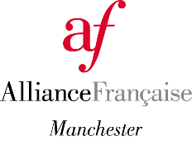 | ASSOCIATION MEMBERSHIP  Application form

I wish to apply: | ☐ as an individual  ☐as the representative of the following organisation:  Click or tap here to enter text.  (Please give information for the representative below)

Surname:  Click or tap here to enter text. | First name(s):  Click or tap here to enter text.
Date of birth:  Click or tap here to enter text. | Occupation:  Click or tap here to enter text.
Phone number:  Click or tap here to enter text. | Email address:  Click or tap here to enter text.
Address:
Click or tap here to enter text.

What is your/your organisation’s main reason for wanting to become an Association Member?
Click or tap here to enter text.

What do you think you/your organisation can contribute to the Alliance Française de Manchester?
Click or tap here to enter text.

The Alliance Française de Manchester will use your personal information to provide the services requested and, if you agree, to send you additional information on upcoming courses and cultural events. The Alliance Française de Manchester will not share your information for marketing purposes with any third party. For more information explaining how we use your personal data, please see our Privacy Policy, available at our reception and on our website.

Would you like to receive our e-newsletter, with information on upcoming courses and cultural events? ☐Yes ☐No

Thank you for your interest in becoming an association member.
Please send your application to director@afmanchester.org. It will be forwarded to the Board for approval and we will be back in touch very soon.
Fees are payable once the application has been approved.

